Assignment 8.3:

Link: https://acadgild.com/blog/transactions-in-hive/

Refer the above given link for transactions in Hive and implement the operations given in the blog using

your own sample data set and send us the screenshot.

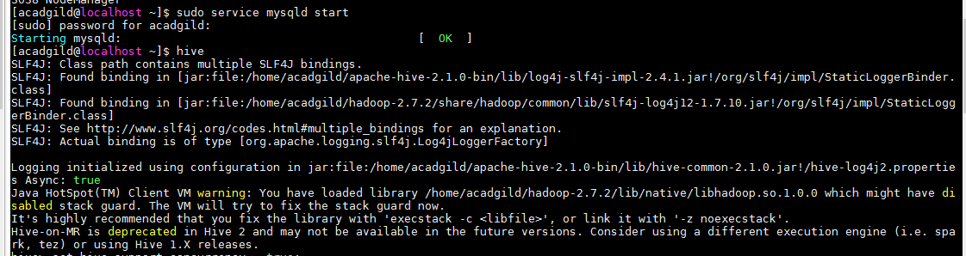

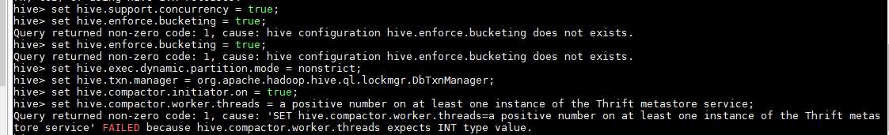



**Creating a Table That Supports Hive Transactions**

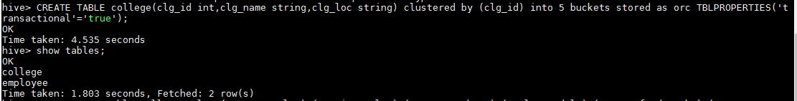

**Inserting Data into a Hive Table**

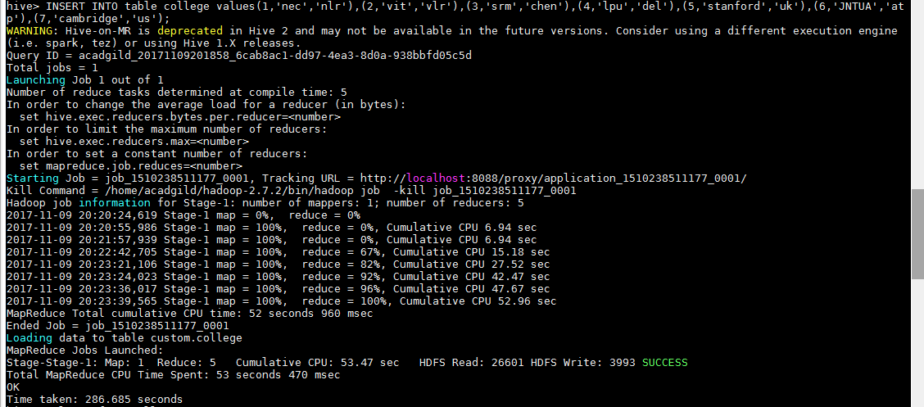

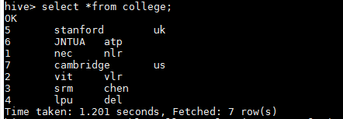

Now if we try to re-insert the same data again, it will be appended to the previous data as shown below:

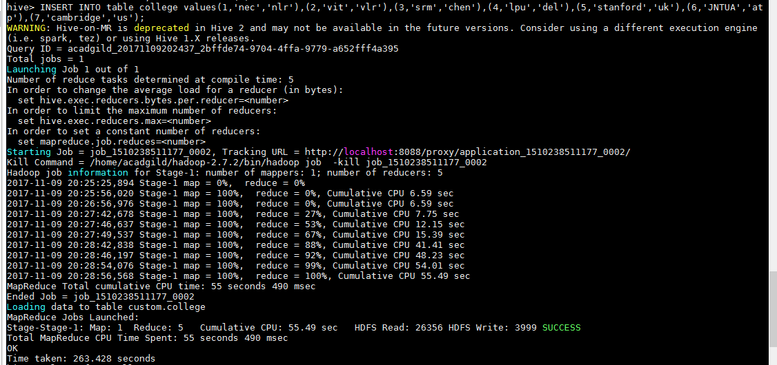

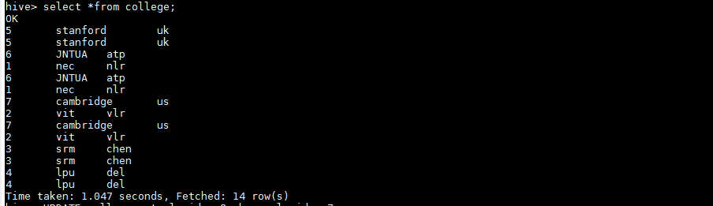

**Updating the Data in Hive Table**



**Now let’s perform the update operation on Non bucketed column**

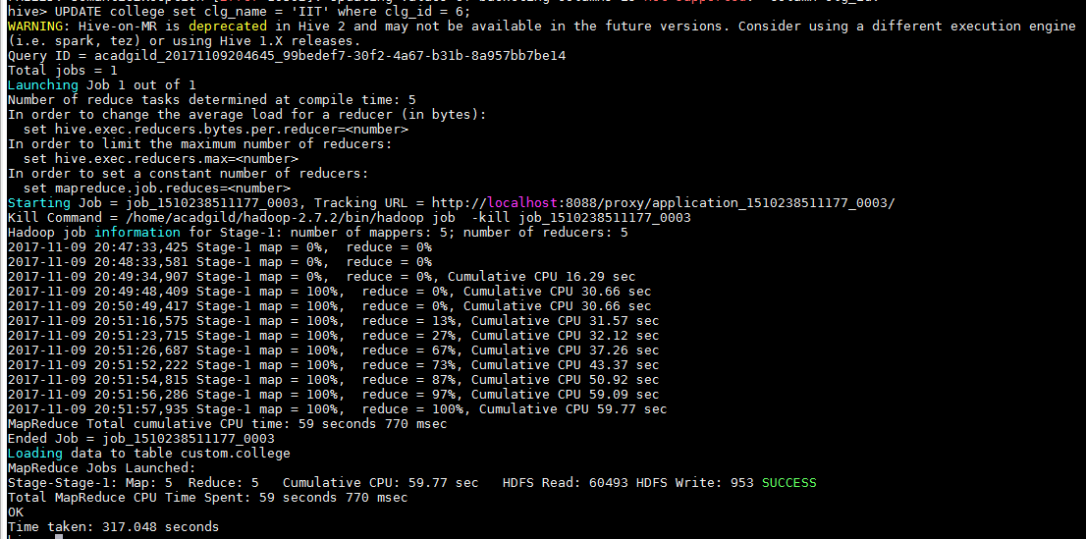

The updated data can be checked using the command ***select * from college.***

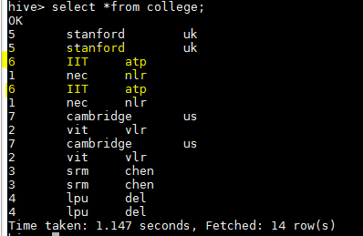

**Deleting a Row from Hive Table**

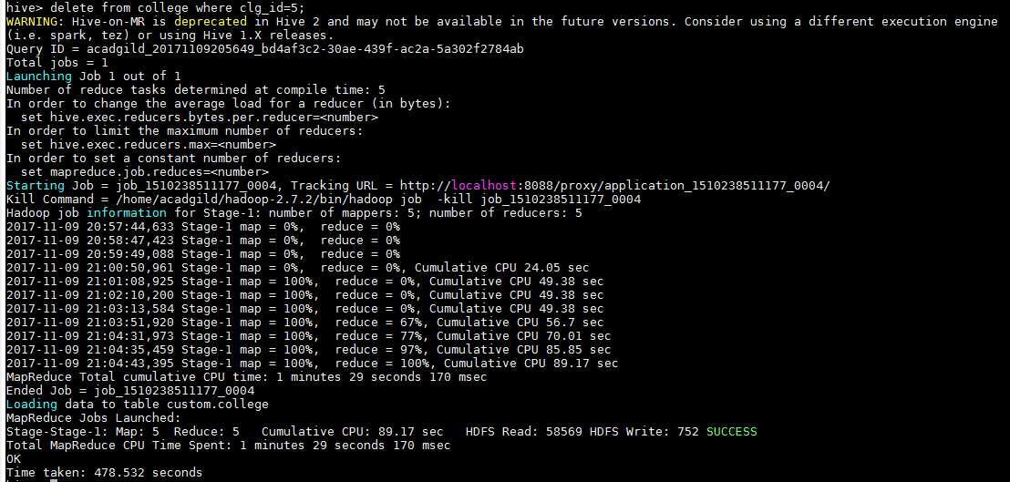

We have now successfully deleted a row from the Hive table. This can be checked using the command **select * from college.**

